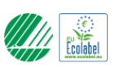

Nordic ecolabel

Dear partner/customer,

This letter is to confirm that ARMOR Print Solutions SAS has received on December 10 2021 by Ecolabelling Sweden, the Nordic Ecolabel license No: 3008 0041 for the product group: 008 Remanufactured OEM Toner Cartridges criteria 5.6 - valid to: December 31 2024.

Yours sincerely

Julien THEBAUD
(R&D Manager)

